Winter 2015 Travelogue Series

Chicago Cultural Center, Renaissance Court
Use Randolph Street Entrance, First Floor

Please call the Renaissance Court to register: (312) 744-4550
There is no cost for attending the presentation.

PRESENTATIONS BEGIN AT 1:00 p.m.
____________________________________________________________________________

Need a little warming up? Some sunshine and blue skies?
Join us on

Tuesday, January 20, 2015

Lynn Funkhouser
Women Divers Hall of Fame
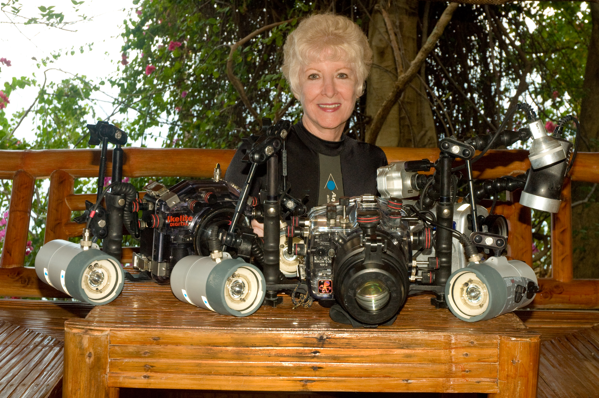

presents

The PHILIPPINES - The Apex of the Coral Triangle

The Philippines is comprised of 7,107 islands. Lynn will be showcasing Anilao and Puerto Galera, considered to be the “Center of the Center of Marine Diversity.” Then you will travel to Dumaguete to learn about her interview with Dr. Angel Alcala, who is responsible for over 400 marine protected areas, and to dive Apo Island and Dumaguete. Then it’s on to Oslob to dive with whale sharks. The final stop is Malapascua, the only known area where graceful oceanic thresher sharks come up to 90 ft. to be cleaned every morning. Lynn continues to amaze us with astounding, award-winning photographs from her dives.

